Lab Assignment-1
School of Engineering and Technology
Course Name & Code: Operating System Lab ENCA252


BCA(AI & DS)-B

(2025–2026)

Prepared by:- Submitted to:-
Harshit Kumar Dr.Jyoti Yadav
2401201057

CPU Scheduling Algorithms (FCFS & SJF)
Introduction:-
CPU Scheduling is an important function of an operating system that decides the order in which processes are executed by the CPU. It helps in efficient utilization of resources and improves overall system performance.
In this assignment, two scheduling algorithms, First Come First Serve (FCFS) and Shortest Job First (SJF), are implemented using Python. FCFS executes processes in the order of arrival, while SJF selects the process with the smallest burst time to reduce waiting time.
The performance of these algorithms is evaluated using parameters such as Completion Time (CT), Turnaround Time (TAT), and Waiting Time (WT). Gantt charts are also used to represent the execution sequence of processes

Objectives:-
- To understand CPU scheduling concepts
- To implement FCFS and SJF algorithms
- To calculate CT, TAT, and WT
- To compare performance of algorithms

Tools Used:-
- Python 3
- Ubuntu Linux

Task 1: Process Creation
We created a Process class with attributes:
- Process ID (PID)
- Arrival Time (AT)
- Burst Time (BT)
We took input from the user and displayed it in tabular form.

Task 1 Code:
class Process:
def __init__(self, pid, at, bt):
self.pid = pid
self.at = at
self.bt = bt
# Input
n = int(input("Enter number of processes: "))
processes = []
for i in range(n):
at = int(input(f"Enter Arrival Time for P{i+1}: "))
bt = int(input(f"Enter Burst Time for P{i+1}: "))
processes.append(Process(i+1, at, bt))
# Display
print("\nPID\tAT\tBT")
for p in processes:
print(f"{p.pid}\t{p.at}\t{p.bt}")

Task 1 Output:-
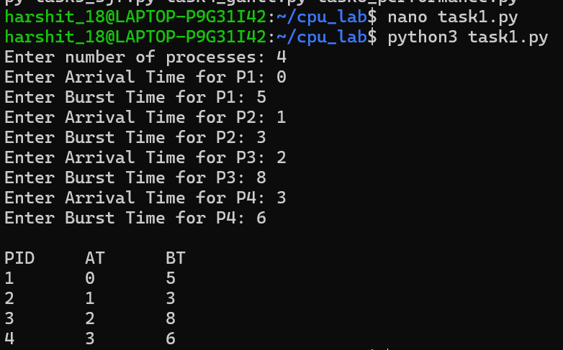
Task 2: FCFS Scheduling
FCFS executes processes in the order of arrival.
Formula:
- CT = Completion Time
- TAT = CT - AT
- WT = TAT - BT
FCFS is simple but may lead to higher waiting time.

Task 2 Code:-
class Process:
def __init__(self, pid, at, bt):
self.pid = pid
self.at = at
self.bt = bt
self.ct = 0
self.tat = 0
self.wt = 0
def fcfs(processes):
processes.sort(key=lambda x: x.at)
time = 0
for p in processes:
if time < p.at:
time = p.at
time += p.bt
p.ct = time
p.tat = p.ct - p.at
p.wt = p.tat - p.bt
return processes
# Input
n = int(input("Enter number of processes: "))
processes = []
for i in range(n):
at = int(input(f"AT for P{i+1}: "))
bt = int(input(f"BT for P{i+1}: "))
processes.append(Process(i+1, at, bt))
# Run FCFS
result = fcfs(processes)
# Output
print("\nPID\tAT\tBT\tCT\tTAT\tWT")
for p in result:
print(f"{p.pid}\t{p.at}\t{p.bt}\t{p.ct}\t{p.tat}\t{p.wt}")

Task 2 Output:-
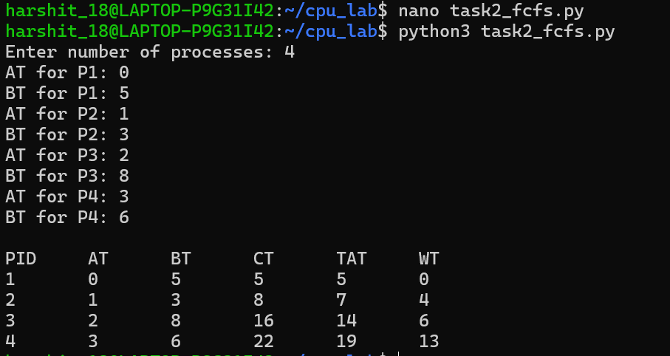

Task 3: SJF Scheduling
SJF selects the process with the smallest burst time.
It reduces average waiting time but may cause starvation.

Task 3 Code:-
class Process:
def __init__(self, pid, at, bt):
self.pid = pid
self.at = at
self.bt = bt
self.ct = 0
self.tat = 0
self.wt = 0
def sjf(processes):
n = len(processes)
time = 0
completed = 0
visited = [False] * n
while completed < n:
idx = -1
min_bt = 9999
for i in range(n):
if processes[i].at <= time and not visited[i]:
if processes[i].bt < min_bt:
min_bt = processes[i].bt
idx = i
if idx != -1:
time += processes[idx].bt
processes[idx].ct = time
processes[idx].tat = processes[idx].ct - processes[idx].at
processes[idx].wt = processes[idx].tat - processes[idx].bt
visited[idx] = True
completed += 1
else:
time += 1
return processes
# Input
n = int(input("Enter number of processes: "))
processes = []
for i in range(n):
at = int(input(f"AT for P{i+1}: "))
bt = int(input(f"BT for P{i+1}: "))
processes.append(Process(i+1, at, bt))
# Run SJF
result = sjf(processes)
# Output
print("\nPID\tAT\tBT\tCT\tTAT\tWT")
for p in result:
print(f"{p.pid}\t{p.at}\t{p.bt}\t{p.ct}\t{p.tat}\t{p.wt}")

Task 3 Output:-
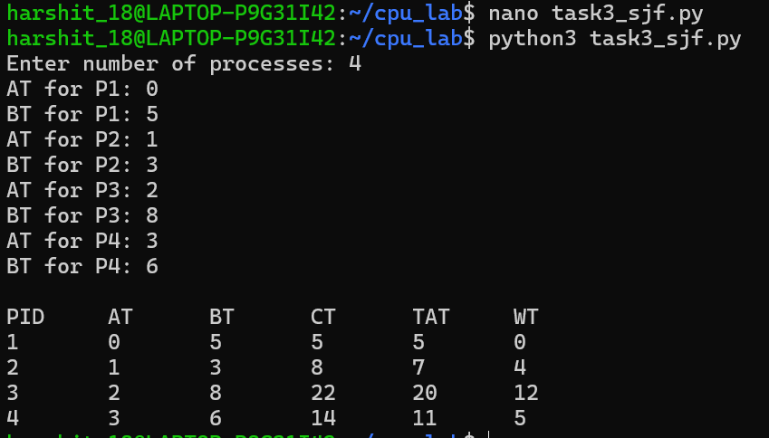
Task 4: Gantt Chart
Gantt chart shows execution order of processes over time.
It helps in visualizing scheduling.

Task 4 Code:-
def gantt(processes):
print("\nGantt Chart:")
for p in processes:
print(f"| P{p.pid} ", end="")
print("|")
print("0", end="")
for p in processes:
print(f"\t{p.ct}", end="")
print()
# Example data
class Process:
def __init__(self, pid, ct):
self.pid = pid
self.ct = ct
processes = [
Process(1, 4),
Process(2, 7),
Process(3, 10)
]
gantt(processes)

Task 4 Output:-
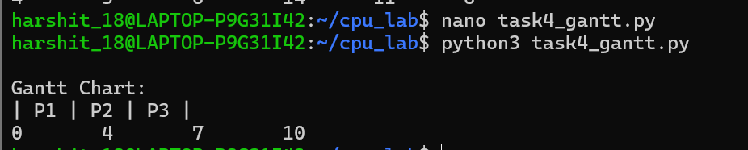

Task 5: Performance Analysis
We calculated:
- Average Waiting Time
- Average Turnaround Time
SJF gave better performance compared to FCFS

Task 5 Code:-
def performance(processes):
total_wt = sum(p.wt for p in processes)
total_tat = sum(p.tat for p in processes)
avg_wt = total_wt / len(processes)
avg_tat = total_tat / len(processes)
print(f"Average Waiting Time: {avg_wt}")
print(f"Average Turnaround Time: {avg_tat}")
# Example use (after FCFS or SJF)
performance(result)
Task 5 Output:-
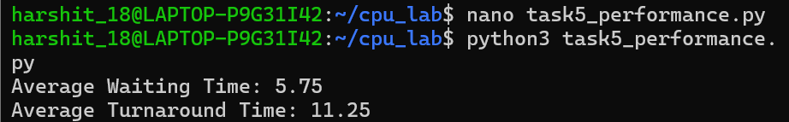

Conclusion:-
In this assignment, we successfully implemented FCFS and SJF CPU scheduling algorithms using Python. It was observed that FCFS is simple and easy to implement, but it may result in higher waiting time. On the other hand, SJF provides better performance by minimizing average waiting time, although it may cause starvation in some cases.
Thus, SJF is generally more efficient than FCFS, but the choice of algorithm depends on system requirements.

References:-
- Operating System Concepts by Silberschatz
- GeeksforGeeks (CPU Scheduling Algorithms)
- Lecture Notes provided by faculty

